Mrs. Matherlee – 6th Grade Science – Syllabus

Contact: matherl@gcsnc.com

**Check grades in PowerSchool, not in Canvas.**

[Here’s help!](https://www.gcsnc.com/domain/1598)

Remind Information:

Here’s how to sign up:

➢ Send a text message to 81010

Mrs. Matherlee’s Core 1 (26) ONLY – text message: @matherl1

Mrs. Matherlee’s Core 2 (36) ONLY – text message: @matherl2

Mrs. Matherlee’s Core 3 (46) ONLY – text message: @matherl3

Mrs. Matherlee’s Core 4 (56) ONLY – text message: @matherl4

[Amazon Wish List](https://www.amazon.com/hz/wishlist/ls/3TEUOAY1M4Q5F/ref=nav_wishlist_lists_1):

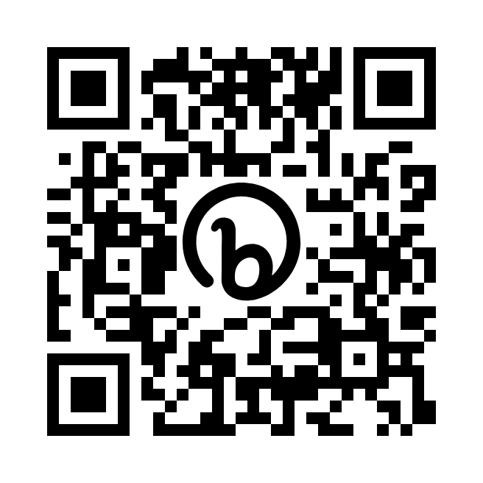

Supplies:

Wired Headphones / Earbuds, Paper, Pencils, Colored Pencils

Homeroom Donations:

Kleenex, Wrapped Candy

Class Expectations:

❑ Be Kind & Respectful

❑ Complete Classwork

❑ Bring Charged Laptop w/ Earbuds

Possible Consequences:

❑ Warning

❑ Silent / Working Lunch

❑ Email / Phone Call Home

❑ Write Up / Meet with Administrator / Teachers

❑ Tests/Projects: 40%

❑ Classwork/Homework: 60%

Students will take a test at the end of each unit.

When a student is absent, it is critical that s/he check Canvas to complete make up work. Go to that day’s science Canvas page, then complete each step on that day.

When absent, send a note or email to the homeroom teacher.

Unit 1 – Matter

Unit 2 – Energy

Unit 3 – Waves

Unit 4 – Living Organisms

Unit 5 – Ecosystems

Unit 6 – Earth in the Universe

Unit 7 – Earth’s Layers

Unit 8 – Soil Conservation